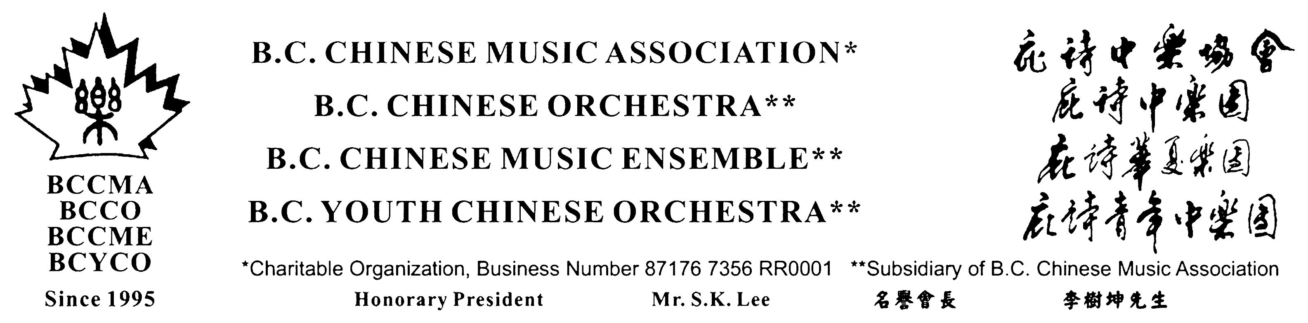

B.C. Chinese Music Association ~ B.C. Chinese Orchestra
20th Anniversary Celebration

~~~ The Daffodil Concert ~~~

Fundraiser for Canadian Cancer Society

May 16, 2015 Saturday 7.30 pm
UBC Chan Centre

The Daffodil Concert celebrating the 20th Anniversary of < B.C. Chinese Music Association > & < B.C. Chinese Orchestra> also fundraising for < Canadian Cancer Society> will be held on May 16, 2015 Saturday 7:30 p.m. at the UBC Chan Centre For The Performing Arts.

This concert presents a unique showcase on the culture of Chinese ethnic instrumental music enhancing multiculturalism in BC. The concert brings together the maestro and the new generation of brilliant young musicians to feature both traditional and contemporary Chinese repertoires for our music lovers.

Don't miss this opportunity to enjoy the joint performance of the B.C. Chinese Orchestra conducted by Ray Zhuo, B.C. Youth Chinese Orchestra conducted by Gloria Wong, the BC Children’s Choir conducted by Dorothy Choi together with B.C. Chinese Music Ensemble : Suona soloist - Zhong-Xi Wu, Zhongruan soloist – Ge-Ling Jiang to be presented in this musical extravaganza. The programs are :

Orchestra: Jasmine, Great Wall Capriccio, Sketches of Tibetans at
Sichuan
Suona Concerto Lady Hua Mu-Lan / Soloist : Zhong-Xi Wu
Zhongruan Concerto Music Poem at Frontier / Soloist : Geling Jiang

Erhu Soli Return from Pasture / Soloist : Nicole Li
Pluck Ensemble Travel around the World /
Percussion & Orchestra Tigers Grinding Teeth
Choir & Orchestra BC Children’s Choir, BC Youth Chinese Orchestra

This is a fundraiser concert for charity with all net proceeds going to Canadian Cancer Society. Tickets at prices of $25.00, $35.00, $45.00 and $100.00 VIP will be available at Ticket Master and few locations. You can contact the organizer – B.C. Chinese Music Association by phone at 604-327-8807or by e-mail at mail@bccma.net for ticketing information.

Let us enjoy the beautiful music to support the cultural and charitable events for the community. Your presence and sponsorship are most welcome.

#303 – 8495 Ontario Street, Vancouver, B.C. V5X 3E8 Canada
Tel: 604-627-8807 Fax: 604-327-8606
E-mail: mail@bccma.net Web: http:// www.bccma.net

